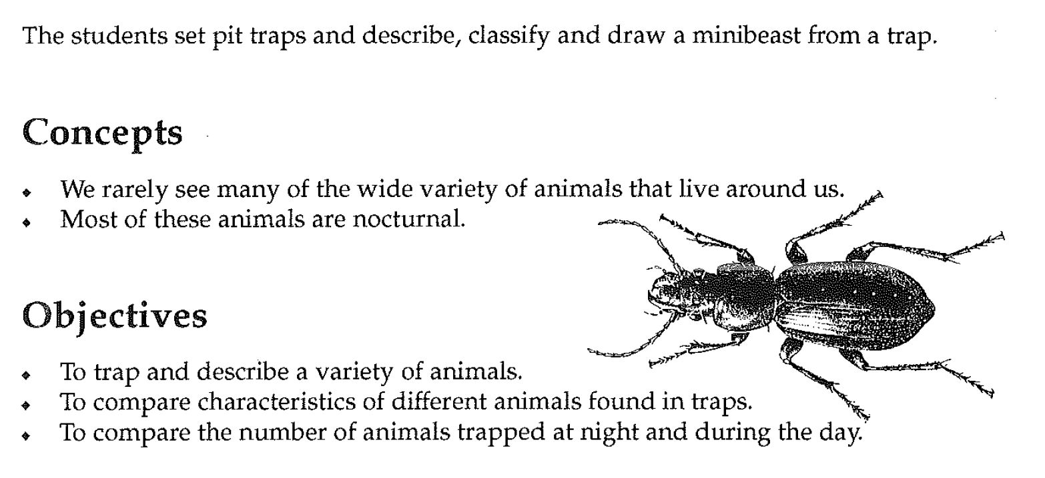

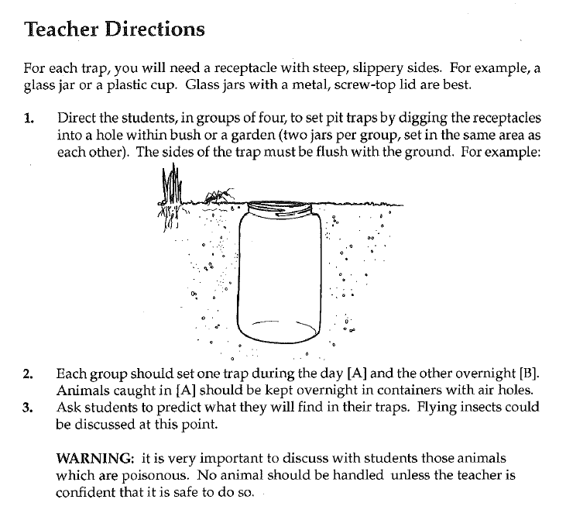

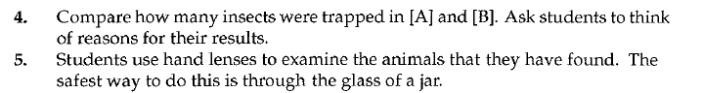

6. Use the Woodland Invertebrates key to attempt to classify 4 different Invertebrates

|  |  |  |
| --- | --- | --- |
| Number | Common Name | Scientific Name |
| 1 |  |  |
| 2 |  |  |
| 3 |  |  |
| 4 |  |  |

7. Email your Science teacher to tell them the names of 4 animals you found. Good Luck

